Wireless & The IoT
  - Lab 5: Hardware! Packets! Beginning to play around with real BLE

Introduction
The purpose of today’s lab is to introduce you to the nrf52840 Dongle, the Nordic Bluetooth ecosystem, the littlest bit of embedded programming, and generally just to play around with some real-world wireless.

The Assignment
I’ll give an overview of the major points, but don’t plan to talk for more than 60-120 seconds. Mostly, it’s go through the lab and start figuring stuff out. Share some of the interesting stuff you found. Not a super formal write-up, just a ‘show that you did this,’ and hopefully, found something fun/interesting/etc.

What to submit?
Please use this document as a template, add your responses directly, and export it as a PDF to Gradescope. Folks are encouraged to collaborate as much as you like with others. If you work with others, please put everyone’s name who worked together below. I believe I have also configured Gradescope to allow “group submission,” so please submit to Gradescope as a group.
___________________________________________________________________________
(your name(S) here)

Part 1: Setup nRF Connect
Nordic has a suite of really nice software tools that help support experimentation with their hardware platforms. Not everything in the nRF Connect panel is supported by the nrf52840 dongle (and something that look like they wouldn’t be, are; e.g. the “RSSI Viewer” works fine, despite saying it’s for the nRF52832; sadly no direct test mode on the dongle).

Download and install the nRF Connect for Desktop tools:
https://www.nordicsemi.com/Products/Development-tools/nRF-Connect-for-desktop

While that’s installing, go ahead and install the nRF Connect app on your phone too [it’s just called ‘nrf Connect for Mobile’ probably easier to search, but here are links nonetheless]:
- https://apps.apple.com/us/app/nrf-connect-for-mobile/id1054362403
- https://play.google.com/store/apps/details?id=no.nordicsemi.android.mcp

By default, the app is just an empty shell that can install sub-apps. Go ahead and install the Bluetooth Low Energy app, the Programmer, and the RSSI Viewer. You can also install the Direct Test Mode app if you want, I’ll bring a few boards that support that for folks to play with.

Once things are installed, plug in your dongle and fire up the Bluetooth Low Energy app. Not much happens until you select a device. It’ll ask to program your device, which you should say yes to. Under the hood, a custom firmware image for this app is being installed. This firmware opens a serial link between the Bluetooth Low Energy app and the dongle, which the app uses to control the dongle and collect data. This basic concept of ‘serial to app’ is how all of the Nordic tools work. Notably, this circumvents the entirety of OS Bluetooth stacks. At no point does the dongle appear to be a Bluetooth peripheral to your OS [well, you can program it with firmware to do that; just not today], rather it’s just a USB serial port.
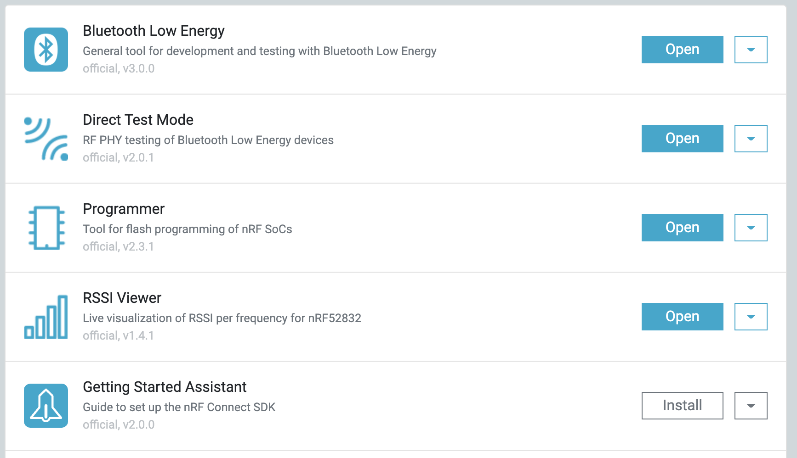
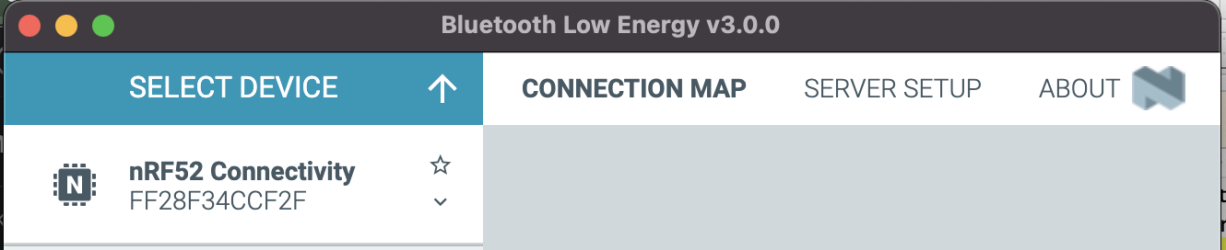
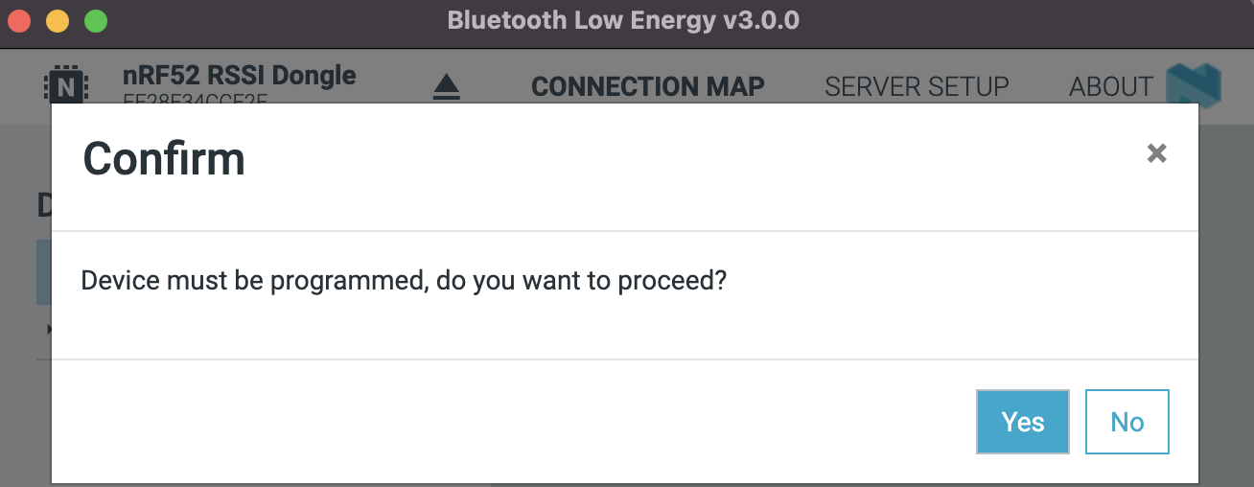

Figures: nRF Connect app; drop-down to select device; Yes to programming; serial conn in log

Play around a little bit with Bluetooth Low Energy app. What devices do you see when you scan? Can you make your device advertise? Can you customize what your advertisement says? Can you see your dongle’s advertisements on your phone? Can you the devices of other folks in class? Can you manipulate the RSSI of your device? What does the RSSI Viewer show?

Part 1: What to Submit
Drop some screenshots / text of anything you found cool or interesting while playing around. Make sure to note a few device addresses of interest, they’ll help with filtering in the next step.

Part 2: Sniffing BLE
Now, we’re going to tie back to Lab 1 (!), and link our dongle to Wireshark. You should already/still have Wireshark installed, but if it’s not on this machine, install Wireshark first.
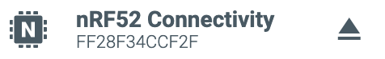
Step 0: Disconnect from the apps you were using

First, grab a copy of the nRF Sniffer app:
https://www.nordicsemi.com/Products/Development-tools/nRF-Sniffer-for-Bluetooth-LE/Download

Head’s Up! This next step will erase the DFU off of your dongle. That means you’ll no longer be able to program the device without an external programmer. (Unfortunately, I don’t think Nordic has a firmware image of DFU + sniffer; though as you’ll see in the Programmer, there’s plenty of space…) I’ll bring a few programmers to the lab for folks to reflash their devices to stock firmware if you want. This post gives more details about what’s going on under the hood:
https://devzone.nordicsemi.com/guides/short-range-guides/b/getting-started/posts/nrf52840-dongle-programming-tutorial

Open the Programmer app, and drag the /hex/sniffer_nrf52840dongle_nrf52840_4.1.0.hex precompiled firmware over for programming.

The sniffer receiver is written in Python. You’ll need Python3 and pyserial >= 3.5. If you don’t have Python3, follow the python install guide. For pyserial, you can run python3 -m pip install pyserial once Python is installed.

First, a quick sanity check that things are working:
$ cd extcap/
$ cp ../doc/example.py .
$ python3 example.py
Could not find device this may print at first :shrug:
Sniffer Device List: [Bluetooth LE device """" ([67, 45, 61, 114, 35, 213, 1]), Bluetooth LE device """" ([2, 80, 215, 201, 50, 109, 1]), Bluetooth LE device """" ([77, 62, 140, 133, 107, 159, 1]), Bluetooth LE device """" ([111, 48, 65, 15, 124, 253, 1]), Bluetooth LE device """" ([253, 36, 251, 90, 19, 135, 1]), Bluetooth LE device """" ([105, 27, 16, 56, 55, 211, 1]), Bluetooth LE device """" ([85, 144, 143, 180, 73, 32, 1]), Bluetooth LE device """" ([226, 45, 78, 106, 96, 29, 1])]
inConnection False
currentConnectRequest None
packetsInLastConnection None
nPackets 4129

Next, we need to install the external capture device ‘extcap’ to wireshark. For this, you need to know where Wireshark was installed on your machine. Inside the wireshark install is an extcap folder that we’ll need to add this new sniffer to:

$ cd /Applications/Wireshark.app/Contents/MacOS/extcap
$ cp -r ~/Downloads/nrf_sniffer_for_bluetooth_le_4.1.0/extcap/* .

Then, you can fire up Wireshark (or, if you already have, Capture Menu Refresh Interfaces).

If everything went well, you now have a new capture interface!
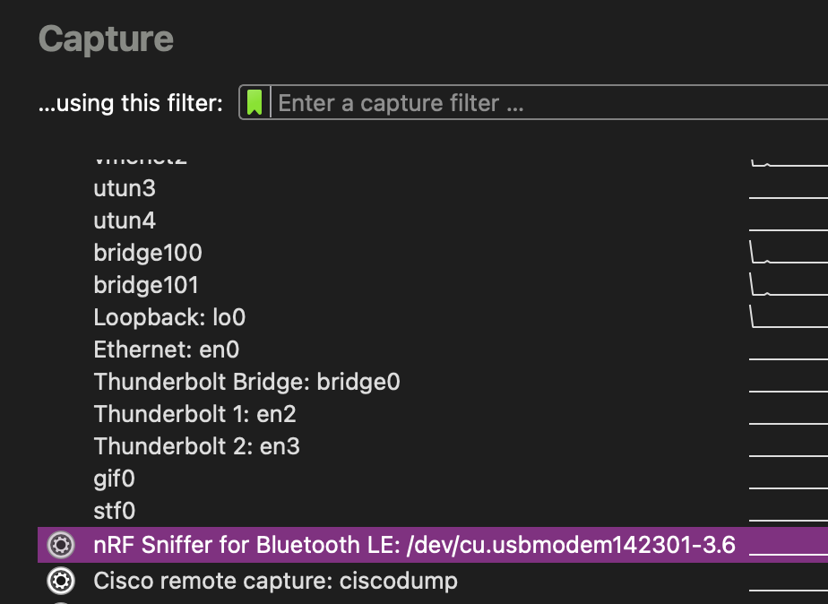

Double click, and start capturing!
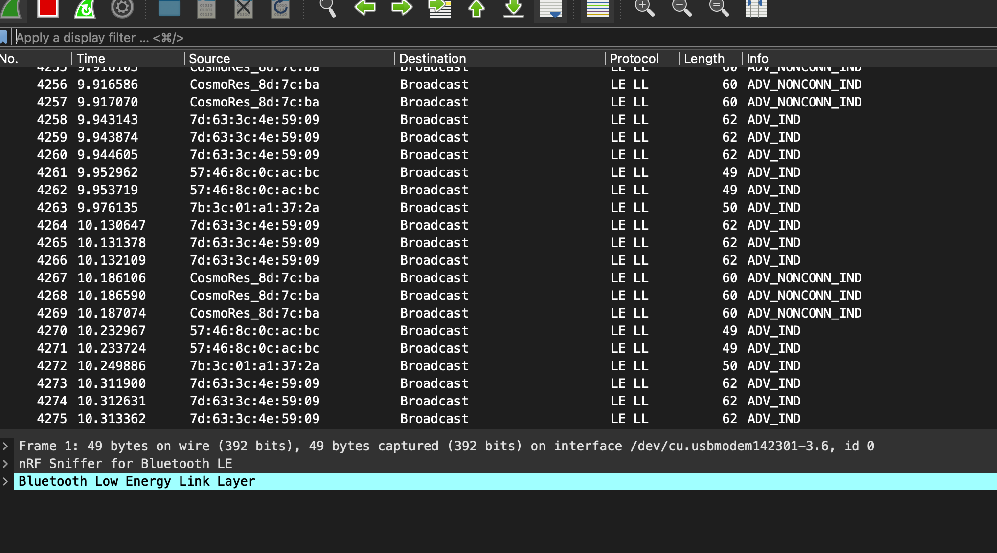

Anything timely around?
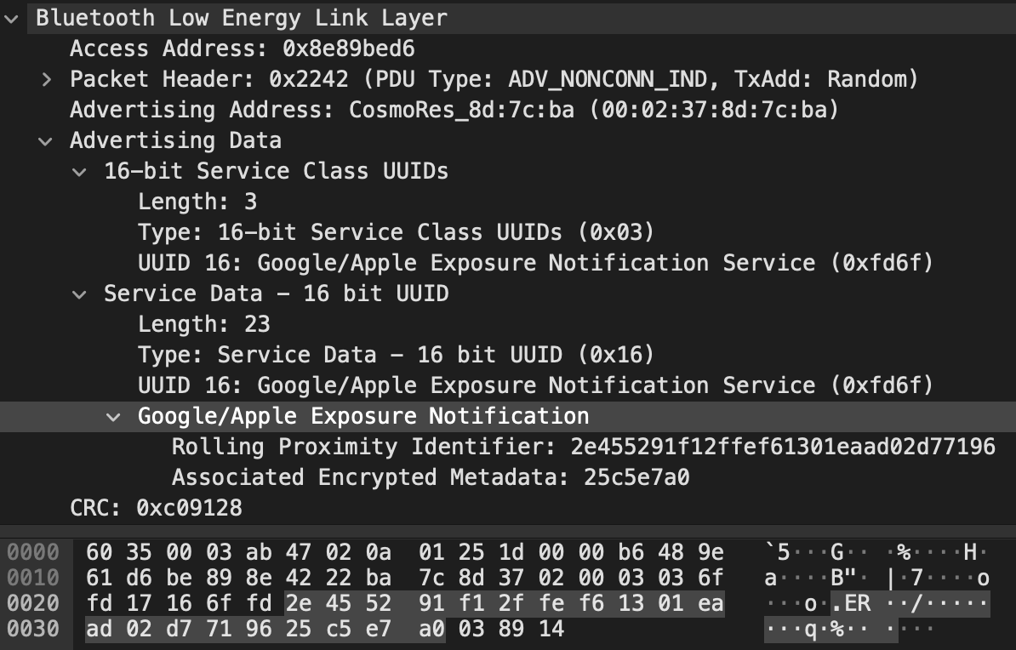

Play around a little bit with the Wireshark captures. Can you identify any packets that are being sent as your devices? Can you identify packets from other folks in class? Look at the protocol breakdown for some advertisements, can you see the major fields we talked about in lecture? Any advertisements you can get meaningful data from (maybe ones others send)?

Part 2: What to submit
Drop some screenshots / text of anything you found cool or interesting while playing around. Were you surprised at the volume of traffic? Any interesting devices you were able to ID?

Insert “back in my day” grumbling here (but kinda really).

